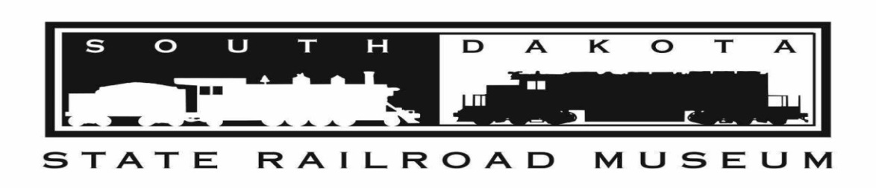

RAILROAD DISPATCH REPORT PAGES—STUDENT LEDGER ART PROJECT
EXHIBIT PERMISSION 2020-2021
SPONSOR: South Dakota State Railroad Museum Ltd.
ELIGIBLE PARTICIPANTS: All accredited South Dakota schools with grades 4-8 and grades 9-12 or grades 4-8 or grades 9-12 (See attached explanation for parent/guardian)

NAME OF SCHOOL DISTRICT (Please print) _______________________________________

NAME OF ART EDUCATOR (Please print) _________________________________________
Mailing address___________________________________________________________

NAME OF STUDENT ARTIST (Please print) ________________________________________
Mailing address___________________________________________________________

ENTRY CATEGORY (Student’s Grade) ____________________________________________
PARENT/ GUARDIAN SIGNATURE (Permission for student to participate in the Ledger Art Project.) Addresses are used for mailing awards, checks, and art work.

__________________________________________________________ ________________
Signature Date

Return form to the student’s Art Teacher. The Art Teacher will mail forms to the South Dakota State Railroad Museum, PO Box 1070, Hill City, SD 57745 or scan the forms and email to sdsrrm@gmail.com.

RAILROAD DISPATCH REPORT PAGES
STUDENT LEDGER ART PROJECT
ACADEMIC YEAR 2020-2021

SPONSOR: South Dakota State Railroad Museum Ltd.

ELIGIBLE PARTICIPANTS: All accredited South Dakota schools with grades 4-8 and grades 9-12 or grades 4-8 or grades 9-12

RAILROAD DISPATCH REPORT PAGES: SDSRM will provide pages

ENTRY CATEGORIES: Student art projects in Grades 4-8 and Grades 9-12

CRITERIA FOR ART PROJECTS
- Art will be submitted to the SDSRM on the railroad dispatch report ledger pages.
- Any media may be used, e.g. oil, water color, charcoal, collage, etc.
- Grades 4-8 the subject must relate to railroads.
- Grades 9-12 the subject must relate to South Dakota history or culture.
- Art teachers the subject must relate to South Dakota history or culture.
- A whole page may be used or the page may be separated into smaller pieces.
- The art may be by an individual student or group of students.
- The art teacher will determine how to organize the art project. For example, the teacher may want a number of students to complete art work on paper and then select the art that will be completed on the ledger page.
- Each school will determine how to select the art projects in each grade category that are submitted to the SDSRM for judging and possible exhibit. For example, the art teacher(s) may decide or the school may select judges to determine

TIMELINE
- Ledger pages mailed or delivered to schools upon selection to participate
- Student art projects may be completed during both Fall 2020 and Spring 2021 school terms
- Student art project entries submitted to SDSRM by April 5, 2021 along with permission form signed by each student’s parent to display and sell the art project
- SDSRM notifies school representative via email when entry and permission received
- Judging of student art completed by April 19, 2021; judge(s) will be selected by the SDSRM
- Art Exhibit opening in Hill City in May 2021 will include student entries from Fall 2020 and Spring 2021 school terms

ART EXHIBIT IN HILL CITY
- Number of art projects in each student category selected for exhibit determined by judges
- Number of art teacher projects for exhibit will be determined by the number of teachers submitting work
- 1st ($100), 2nd ($75), 3rd ($50) prizes and ribbons in each category awarded to students; judges may choose to award honorable mention ($25); if a winning art project is by more than one student, the award funds are divided among them
- Art may be backed and shrink wrapped for display
- Exhibit will be at the South Dakota State Railroad Museum May through mid-October 2021.
- Art for exhibit will be displayed on the SDSRM website
- Student art for exhibit will be for sale with funds split 50% to the student artist(s) and they donate 50% to SDSRM to fund the next Ledger Art Project in 2021; if an art project is by more than one student, the 50% of the sale price is divided among them. Students may specify that their work is not for sale.
- Museum staff will consult with the judges and as possible with teachers to determine the sale prices for student art
- Art teachers will specify if their work is for sale or not for sale; if for sale, the teacher specifies the sale price and funds will be split 50% to the art teacher and they donate 50% to SDSRM to fund the next Ledger Art Project in 2022.
- Buyers may choose to take with them the art they purchased or leave the art through the end of the Exhibit. Art left through the end of the Exhibit will be mailed to the buyer.
- If the school, teacher or student wants art that is not sold to be returned, they must pay postage.

